 | CITY OF LOS ANGELES
Palms Neighborhood Council  Area Representatives  Kay Hartman, President  Jeff Mcilvain, Vice President  Vacant, Secretary  Ana Garcia Lima, Treasurer  Vacant, Community Org. Rep  Maria Bajenov, Residential Rep. A  Mateo Acosta, Residential Rep. B  Richard Kerr, Residential Rep. C  John Giarratana, Residential Rep D  Jillian Brandt, Residential Rep. E  Reza Akef, Business Rep. 1  Vacant, Business Rep. 2  Caris Lee, Youth Representative |  | CALIFORNIA |  | 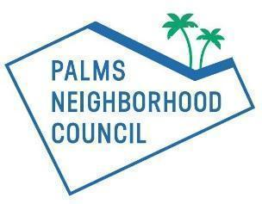  10008 National Blvd. #210  Los Angeles, CA 90034  Email: info@palmsnc.la  Website: www.palmsnc.la  Facebook: facebook.com/PalmsNC  X: @palmsnc  Instagram: @palmsnc

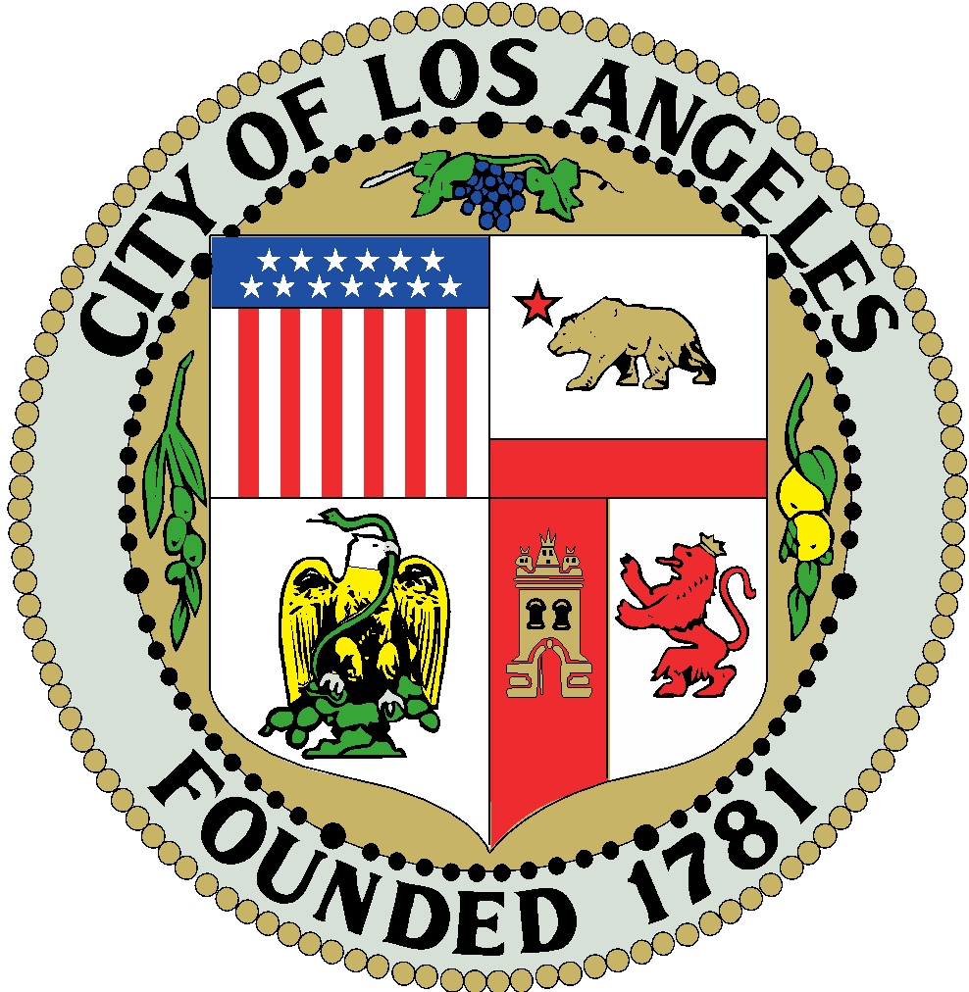

PALMS NEIGHBORHOOD COUNCIL

General Assembly Special Meeting Agenda
The IMAN Center
3376 Motor Ave, Los Angeles, CA 90034 (onsite parking available)
Wednesday, November 5, 2025 – 7:00 p.m.

Si requiere servicios de traducción, favor de avisar al Concejo Vecinal 3 días de trabajo (72 horas) antes del evento. Por favor contacte Kay Hartman, Presidente, por correo electrónico al Kay.Hartman@palmsnc.la para avisar al Concejo Vecinal.

PUBLIC INPUT AT NEIGHBORHOOD COUNCIL MEETINGS Comments from the public on other matters not appearing on the agenda that are within the Board’s jurisdiction will be heard during the General Public Comment period. Please note that under the Brown Act, the Board is prevented from acting on a matter that you bring to its attention during the General Public Comment period; however, the issue raised by a member of the public may become the subject of a future Board meeting. Public comment is limited to two minutes per speaker, unless adjusted by the presiding officer.
The Neighborhood Council system enables meaningful civic participation for all Angelenos and serves as a voice for improving government responsiveness to local communities and their needs. We are an advisory body to the City of Los Angeles, comprised of stakeholder volunteers who are devoted to the mission of improving our communities.

- CALL TO ORDER AND ROLL CALL
  - Call to Order (Hartman)
  - Roll Call (Hartman)
- SPECIAL ORDERS
  - ADDRESS by Councilmember Katy Yaroslavsky
  - DISCUSSION Questions, including those from the public, for the Councilmember
- ANNOUNCEMENTS
  - Please plan to attend the November 8 Westside Summit, an afternoon of conversation, connection, and community at the Mar Vista Community Center, 11430 Woodbine St, from 11:00 a.m. to 2:00 p.m.
  - Please plan to attend the November 13 meeting to discuss a new mural on Overland Blvd with CD 5 at the IMAN Center, 3376 Motor Ave, from 6:00 p.m. to 8:00 p.m.
  - The Neighborhood Council is looking for people to join our committees. See our list of committees on our website at https://palmsnc.la/committees/. To join, please send an email expressing your interest to president@palmsnc.la.
  - Palms Neighborhood Council Committees Community Resources:
    - Renters Rights and Affordable Housing Advocacy Committee Resource List
    - Racial and Social Justice Resource List
- GENERAL PUBLIC COMMENT ON NON-AGENDA ITEMS & MULTIPLE AGENDA ITEM PUBLIC COMMENT
- COMMUNITY & GOVERNMENT REPORTS – No reports this month
- Office of Councilmember Katy Yaroslavsky – Vanessa Saldana Vanessa.Saldana@lacity.org
- Office of Mayor Karen Bass – Jennifer Hull jennifer.hull@lacity.org
- Office of County Supervisor Lindsey Horvath – Katie Abrams KAbrams@bos.lacounty.gov
- Office of LAUSD Board of Education Sherlett Hendy Newbill – Jewett Walker, Jr. jewett.walkerjr@lausd.net
- Office of State Assemblymember Isaac Bryan- Karen Calderon Karen.Calderon@asm.ca.gov
- Office of State Senator Lola Smallwood-Cuevas – Carlos Penilla Carlos.Penilla@sen.ca.gov
- Office of Congress Representative Ted Lieu – Mia Thiagarajan Mia.Thiagarajan@mail.house.gov
- Office of Congress Representative Sydney Kamlager Dove – Jackson Benarroch Jackson.Benarroch@mail.house.gov
- Los Angeles Police Department Pacific Division – Senior Lead Officer (SLO) Adrian D. Acosta 37285@lapd.online
- Los Angeles Fire Department Battalion 18 – Chief Shin Black Shin.Black@lacity.org
- Department of Neighborhood Empowerment – Helena Doub helena.doub@lacity.org
- Other Government Departments and Community Organizations
- Community Forest Advisory Committee
- Budget Advocates
- COMMITTEE REPORTS
  - Business Relations (Akef)
  - Education/Youth/Community (Hartman)
  - Executive (Hartman)
  - Green (Miller)
    - September 23, 2025 Meeting Minutes
  - Outreach (Hartman)
  - Planning and Land Use Management (Hartman)
  - Transportation and Infrastructure (Kaiser)
    - October 9, 2025 Meeting Minutes
  - Unhoused and Public Safety (Akef)
- EXECUTIVE REPORTS
  - President
    - The Neighborhood Council is looking for people to fill the roles of Secretary, Community Based Organizations Representative, and Business Representative. Please send a resume and cover letter to president@palmsnc.la to apply. Board members are also welcome to apply.
    - Looking for somebody to be the first alternate representative to the Westside Regional Alliance of Councils – WRAC (meets the third Monday at 6:30 p.m. on Zoom). If you are interested in this position, please contact Kay Hartman, president@palmsnc.la.
    - A reminder to committee chairs that committee members who are not members of the board and who have not previously signed the Code of Conduct need to do so. Please scan the signed document and email it to president@palmsnc.la. Let Kay know if you have any questions.
    - We are lost our Secretary last month. Until we find a new Secretary, the tasks are divided among those who volunteered and the Executive Committee. You can view the assignments here.
  - Treasurer
    - Palms Neighborhood Council Budget Report

- REGULAR CONSENT AGENDA ITEMS
    - MOTION to approve the October 1, 2025 General Assembly Meeting Minutes
    - MOTION to remove Richard Kerr from the Unhoused and Public Safety Committee
    - MOTION to add Amanda McDaniel to the Transportation and Infrastructure Committee as member
    - MOTION to remove Katrina Kaiser from the Transportation and Infrastructure Committee and thank them for their service
    - MOTION to appoint Sonia Garfinkel as chair of the Transportation and Infrastructure Committee
    - MOTION to remove all members from the Education/Youth/Community Committee and decommission the Committee
    - MOTION to remove all members from the Business Relations Committee and decommission the Committee
    - MOTION to remove all members from the Outreach Committee and decommission the Committee
    - MOTION to create a new Community Engagement Committee with Kay Hartman chair, Jeff Mcilvain member, Caris Lee member, Tosin Attah member, and Reza Akef member
    - MOTION to authorize the Palms Neighborhood Council to submit a CIS to oppose unless amended Council File 25-1141 to create a plan to replace dying and unsustainable trees across the City
    - MOTION to authorize the Palms Neighborhood Council to submit a CIS to oppose unless amended Council File 25-1036 to set a minimum indoor temperature, report on options to expand and align incentive and efficiency programs that allow renters to access and install energy-efficient air conditioning equipment, and report on existing renewable energy and energy-efficiency incentive programs available to apartment building owners
    - MOTION to authorize the Palms Neighborhood Council to send a letter requesting speed humps or stop signs at the intersection of Exposition and Cardiff
    - MOTION to authorize the Palms Neighborhood Council to sign onto the LA 28 Biodiversity Coalition supporting a requirement for all new above ground Metro bus and rail stops/stations to include space for, planting of, and maintenance for a large canopy native species tree to provide shade, offset the heat-island effect, and support biodiversity in our urban forest
- FUNDING CONSENT AGENDA ITEMS
    - MOTION to approve the June 2025 MER
    - MOTION to approve the July 2025 MER
    - MOTION to approve the August 2025 MER
    - MOTION to approve the September 2025 MER
    - MOTION to authorize the Palms Neighborhood Council to spend up to $500 for community cleanups
      - The prospective dates in 2026 are March 8, June 13, September 13, and December 13. All dates include a cleanup. The June 13 date includes an audit of the collection.
      - Another date desired in 2025 is December 14.
- OLD BUSINESS
  - DISCUSSION December 7 Metro Ride-Along to LAX status
  - The Outreach Committee would like to see us table once a month. It is asking each committee to pick a time to staff a table and talk to stakeholders. Sign up in this spreadsheet
- NEW BUSINESS
  - MOTION to approve a $500 NPG for Pacific Area Boosters Association
    - IRS Letter of Determination
    - Event Budget
    - Event Flyer
- ADJOURNMENT
  - Next meeting is scheduled for December 3, 2025 at 7:00 p.m. in person at the IMAN Center.

ALL SUPPLEMENTALS

As a covered entity under Title II of the Americans with Disabilities Act, the City of Los Angeles does not discriminate on the basis of disability and upon request will provide reasonable accommodation to ensure equal access to its programs, services, and activities. Sign language interpreters, assistive listening devices, or other auxiliary aids and/or services may be provided upon request. To ensure availability of services, please make your request at least 3 business days (72 hours) prior to the meeting by contacting the Department of Neighborhood Empowerment by calling (213) 978-1551 or email: NCsupport@lacity.org.

Public Posting of Agendas –
Neighborhood Council agendas are posted for public review as follows:
- Woodbine Park Kiosk, 3409 S. Vinton Ave
- https://palmsnc.la/
- You can also receive our agendas via email by subscribing to L.A. City’s Early Notification System (ENS)

Notice to Paid Representatives –
If you are compensated to monitor, attend, or speak at this meeting, City law may require you to register as a lobbyist and report your activity. See Los Angeles Municipal Code Section 48.01 et seq. More information is available at ethics.lacity.org/lobbying. For assistance, please contact the Ethics Commission at (213) 978-1960 or ethics.commission@lacity.org.

Public Access of Records –
In compliance with Government Code section 54957.5, non-exempt writings that are distributed to a majority or all of the board in advance of a meeting may be viewed at our website: https://palmsnc.la/ or at the scheduled meeting. In addition, if you would like a copy of any record related to an item on the agenda, please contact Kay Hartman, President, at Kay.Hartman@NeighborhoodCouncil.org.

Reconsideration and Grievance Process –
For information on the NC’s process for board action reconsideration, stakeholder grievance policy, or any other procedural matters related to this Council, please consult the NC Bylaws. The Bylaws are available at our Board meetings and our website https://palmsnc.la/.

